**Stationery billing system**

**Introduction –**

**Stationery billing system is a project that manages and stores the billing information electronically according to customers needs. The system helps both the customer and the seller to keep a constant tract of all the books available in the store.  
The project titled Stationery Billing System is Stationery Billing Software for monitoring and controlling the billings in the stationery store. The project Stationery Billing System is developed in C language, which mainly focuses on the basic operations in a library like Generate Invoice, Show All Invoices, Search Invoice and after all commands Exit returning back to secure page where no operations will not be held.  
The project Stationery Billing System gives us complete commands about the billing systems. We can generate invoice for new customers and retrieve the details of the customer by simply tying the same name in the system.**

**Objectives –**

1. **To build a system that can receive input and generate automatically output in easy way and short time.**
2. **To build a monitoring system that is able to monitor and manage all billing operations efficiently.**
3. **Give an opportunity to the seller to reduce mistakes that always happen during manual method for billing.**
4. **To store properly the store items in billing to maintain their security by missing any items to be added in bill due to fast and convenient billing system.**
5. **To enter and preserve details of the various items and keep a track on billing system.**

**Benefits –**

* **Record Maintenance.**
* **Web-Based Solution.**
* **Saves Time and Cost.**
* **Secure and Reliable.**
* **Increases Efficiency.**
* **Simple and Easy to Use.**

**Features with Timeline –**

1. **Major activities of the system is automated, which increases its throughput**
2. **The system is fast, user friendly and interactive**
3. **The information entering process is more accurate and clear**
4. **Better data management facility in terms of maintaining bills which are added in system manually.**

**Defining our system –**

1. **Generate Invoice**
2. **Show All Invoices**
3. **Search Invoices**
4. **Exit**

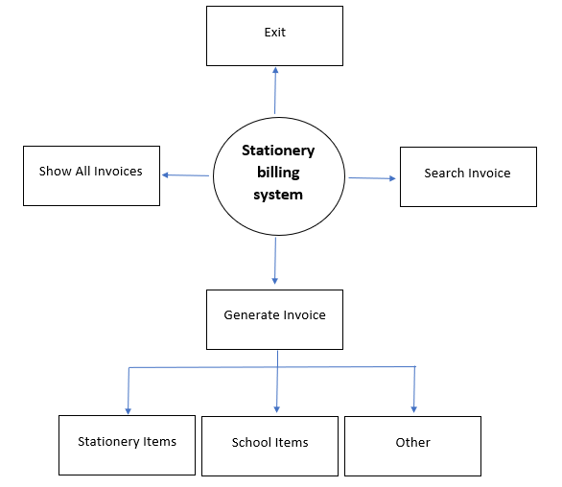

**4W’s and 1H –**

**Who**

**The Stationery billing system is an application used by the stationery sellers for maintaining the billing and customer items in just 1-2 steps to add in bill and every time it will the bill with proper SGST and CGST and will also mention the amount on the bill also.**

**What**

**Stationery billing system is a software that helps to maintain a database that is useful to enter new bills or take the information of the customer after getting sold also. It is very tedious to enter the billing information manually so here this project come into handy.**

**When**

**This Stationery billing system is very useful when there are large number of customers are waiting in line just for giving the money and taking the item which he chosen. The seller can use this software as the purpose of making the bills of the customers and will helpful for managing the time conveniently.**

**Where**

**The Stationery billing system is nowadays essential for generating bills the receiving the information of the customer in seller’s software. They can use this software as a purpose of the Generate Invoice, Show All Invoices, Search Invoice and after all commands Exit returning back to secure page where no operations will not be held.**

**How**

**This project is implemented to do the bill generating, showing the invoices and searching the invoices for a particular customer.**

**Swot Analysis –**

**Strengths**

* **Simple & Easy to Use.**
* **Increased Billing Efficiency.**
* **Efficient Cloud Data Management.**
* **Highly Secure, Scalable & Reliable.**
* **Mobile Access.**

**Weakness**

* **The data stored is prone to cyber hacks.**
* **May be complicated to operate.**
* **Risk of computer virus.**

**Opportunities –**

**The stationery billing system leaks outward into new spaces, spaces which it didn’t inhabit before, such as reading lists repositories, billing systems, research data management and so forth. Furthermore, it is likely that the future of billing systems will consist of a mixture of open and closed systems as well as local and shared (or hosted) services. With an increasing move towards closed platforms (like Facebook, for example) and proprietary ecosystems (like Apple), libraries will be required to navigate these different spaces and ecosystems.**

**Threats –**

**Sellers now add and retrieve data from databases to help better manage inventory and the like, but some stores don’t have the right data encryption practices in place. This can often lead to lost data and sometimes, the data easily obtainable or stole by criminals.**

**High Level Requirements –**

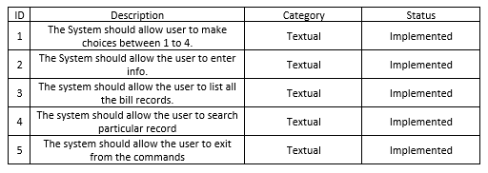

**Low Level Requirements –**

